# Pharmacy

***Quick Summary:*** In the past few years, ordering medicine and receiving care online have become very common among patients in the USA.

Sensing the change in consumer behaviour, several pharmacies have digitized their presence. However, thousands of local pharmacies still operate only brick-mortar stores.

If you are one of them, you will find this blog very interesting as we will discuss everything you need to know to create a pharmacy website for your drug store with some game-changing features.

## Quick Links:

[1. Why do patients prefer to access pharmacy services online?](https://www.syscreations.com/pharmacy-website/#Why%20do%20patients%20prefer%20to%20access%20pharmacy%20services%20online?)

[2. Why is it beneficial to have your own pharmacy website?](https://www.syscreations.com/pharmacy-website/#Why%20is%20it%20beneficial%20to%20have%20your%20own%20pharmacy%20website?)

[3. What is the process of creating a website for pharmacy?](https://www.syscreations.com/pharmacy-website/#What%20is%20the%20process%20of%20creating%20a%20website%20for%20pharmacy?)

[4. The differences you must know between website, web app and mobile app](https://www.syscreations.com/pharmacy-website/#The%20differences%20you%20must%20know%20between%20website,%20web%20app%20and%20mobile%20app)

[5. What to choose between a website, web app and mobile app for your pharmacy?](https://www.syscreations.com/pharmacy-website/#What%20to%20choose%20between%20a%20website,%20web%20app%20and%20mobile%20app%20for%20your%20pharmacy?)

[6. Features that you should add to your online pharmacy platform](https://www.syscreations.com/pharmacy-website/#Features%20that%20you%20should%20add%20to%20your%20online%20pharmacy%20platform)

[7. Why should you also add telemedicine features to your online pharmacy platform?](https://www.syscreations.com/pharmacy-website/#Why%20should%20you%20also%20add%20telemedicine%20features%20to%20your%20online%20pharmacy%20platform?)

[8. We deal with complex pharmacy technology every day. Building a web or mobile app for pharmacy is a cakewalk for us!](https://www.syscreations.com/pharmacy-website/#We%20deal%20with%20complex%20pharmacy%20technology%20every%20day.%20Building%20a%20web%20or%20mobile%20app%20for%20pharmacy%20is%20a%20cakewalk%20for%20us!)

**Why do patients prefer to access pharmacy services online?**

The idea of ordering medicine and receiving care online is really convenient, especially for old age and disabled people as well as parents and working professionals as they do not need to wait in a queue and find the dedicated time.

The following are the other reasons.

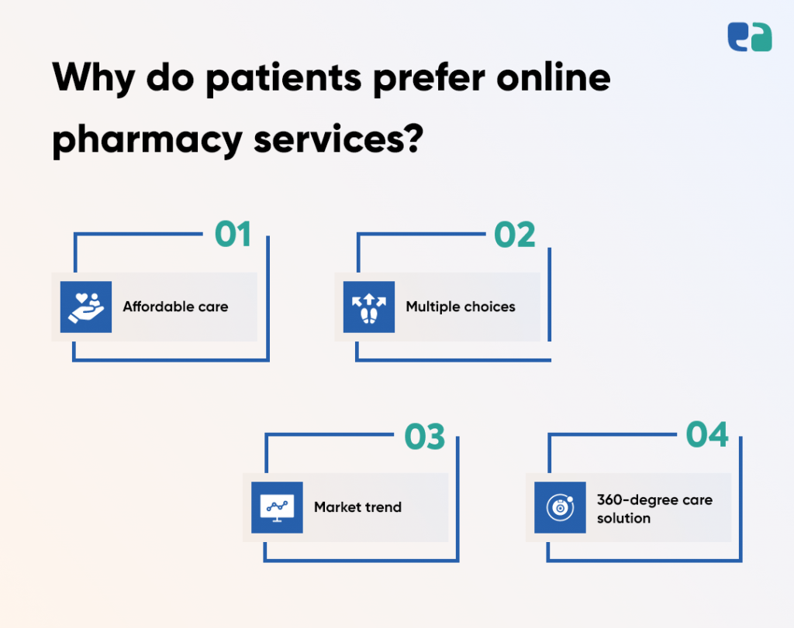

**1. Affordable care**

By ordering medicine and receiving care online, patients eliminate their need for travelling and taking dedicated time out from their work. This results in indirect cost savings.

**2. Multiple choices**

Patients have the flexibility to choose between multiple online pharmacies and hundreds of listed healthcare providers. In offline practice, patients never receive such flexibility.

**3. Market trend**

It is not just medicine, there are all essential items available online. After utilizing online services as part of the compulsion during the period of the pandemic, people now get habituated to prioritizing online services over offline services.

**4. 360-degree care solution**

Several modern and popular pharmacy stores have rolled out telemedicine services from their existing online pharmacy platforms. With this, patients are now able to access both primary care and pharmacy services from a single platform.

There are multiple other reasons. However, all reasons lead to a simple conclusion – people opt-in more for online pharmacy services as it is affordable, convenient and rapid.

**Why is it beneficial to have your own pharmacy website?**

In simple terms – owning a pharmacy website for a pharmacy store is a matter of survival!

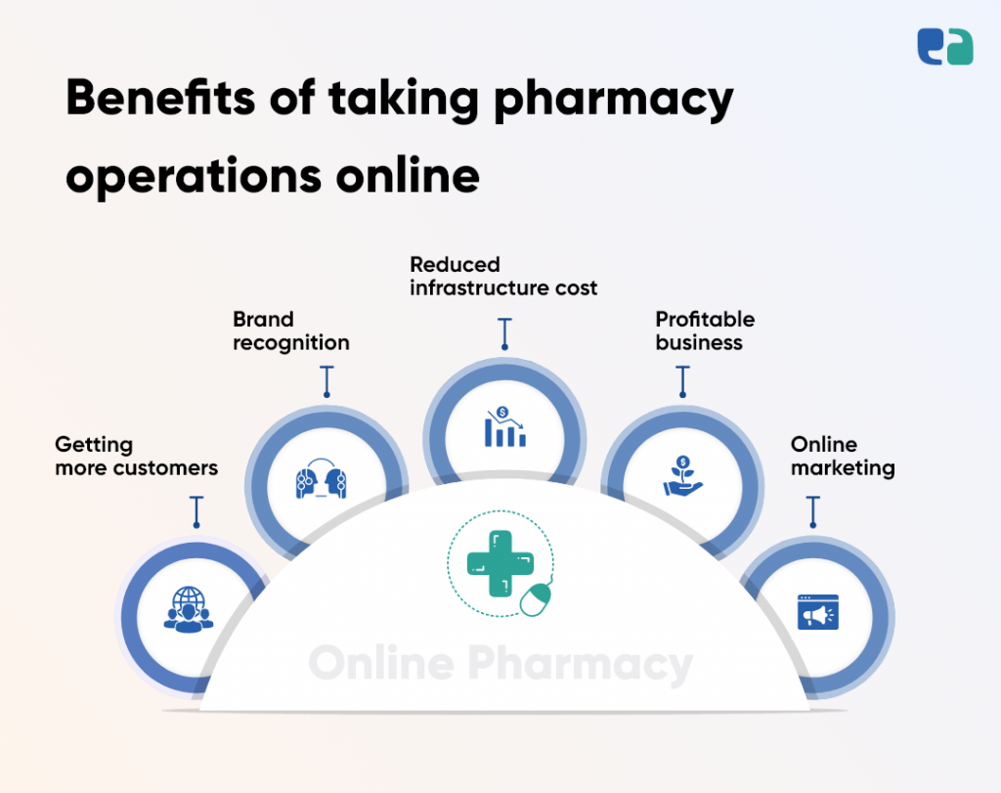

**1. Getting more customers**

One of the biggest advantages of having an online pharmacy is getting a larger audience. You can increase your customer base by interacting with them, offering them personalized deals and you can turn them into loyal customers.

**2. Brand recognition**

Most importantly, It will help create a brand image for your pharmacy store. The more market you capture, the more trust you will have in the customer and the more value you create for the brand. This will help with customer retention.

**3. Reduced infrastructure cost**

In this digital era, users or patients don’t prefer to go out (especially after COVID), and providing them what they want at the doorstep will benefit them as well as a pharmacy. Yes, pharmacies can dramatically reduce their infrastructure cost as they now only require a small operational center and a warehouse.

**4. Profitable business**

Relying on other medicine delivery companies won’t get you much of a profit since they have a higher commission rate. Making something of your own is very important when you want to capture the local market and make loyal customers.

**5. Online marketing**

There are endless possibilities to grow the business with the help of digital marketing. Growing the business is completely in your hand. With the help of digital and social media marketing, you can increase your customer base.

**What is the process of creating a website for pharmacy?**

There is a very common misconception that building a website, web app or mobile app is only about coding. But that’s not true.

Coding is only 20% of the pharmacy website development process. Rest 80% of the process includes discovery, documentation, workflows, UI/UX, coding, testing, piloting and lastly launching.

Let us explain each phase of the process in better detail.

**1) Discovery**

The discovery phase is more focused on requirement gathering, assessing the requirements, finding new possibilities, setting up the KPIs and planning execution.

**2) Documentation**

From features to compliance requirements, everything gets documented here. This document is very important even after the launch of the pharmacy website.

**3) Workflows**

How users interact with your pharmacy website and how you drive their user journey forward define the success of the pharmacy website. Thus, it is mandatory to define the workflows and create a pharmacy website according to those workflows,

**4) UI/UX**

If you skip this, your pharmacy website ends up as a disaster. Because the website’s UI/UX is the first thing that users notice. A good UI/UX inspires users, gives good vibes of the company and helps you earn user trust by representing your brand.

**5) Coding**

Based on the UI/UX provided by the designers, developers code the website. Out of all phases of pharmacy website development, the development or coding phase continues for months.

**6) Testing**

QA testers now take over. They utilize manual and automated testing approaches and test the built website to find out bugs in it. Here it is worth mentioning that it is never feasible to build a 100% bug-free website or app.

**7) Piloting**

The ready website is presented to you as a whole and provided you with basic training to perform operations from its admin panel.

**8) Launch**

Your pharmacy website is finally made live for users.

[**You must read: How to start online pharmacy in the USA?**](https://www.syscreations.com/start-online-pharmacy/)

**The differences you must know between website, web app and mobile app**

When you decide to take your pharmacy online, you do have a choice to choose between a website, web app and mobile app. So, here sharing a quick comparison.

**Website:**

A website is limited to only content. It contains information about pharmacy in graphical and textual format. It does not support some useful features required to run pharmacy operations online such as order tracking, inventory management, separate user/admin/pharmacy sign in etc.

**Web app:**

A web app is the advanced version of a website. Like a website, it opens on web browsers but supports all advanced features. It in fact supports some features like mobile apps such as notifications, background updates, database integration, etc.

**Mobile app:**

A mobile app is the superior one. It has a very large scope of innovation and supports all advanced features which take user experience to the next level. To access it, you have to install it from either Google Play Store or Apple App Store.

**What to choose between a website, web app and mobile app for your pharmacy?**

Decide this carefully as this one decision will define your budget and the success of your attempt to digitize your pharmacy.

**You should go for website:**

* If your agenda is to just share your pharmacy information with your customers
* If you have a very low investment cap – below $5K

**You should go for the web app:**

* If your agenda is to provide online pharmacy services to users such as medicine delivery, online prescription refill, telemedicine etc
* If you have a medium investment cap

**You should go for the mobile app:**

* If you’re looking for a future-ready product for your pharmacy
* If you want to deliver an exceptional user experience to the users
* If you want to set your pharmacy apart
* If you have a medium-high investment cap

**Features that you should add to your online pharmacy platform**

Before we move ahead, let us clarify that the majority of these features are only supported by a web app and a mobile app and not a website.

**User-centric features:**

* User profile
* Smart search
* Drug information
* Drug comparison
* eCommerce platform
* Payment
* Prescription transfer
* Prescription renewal
* Order tracking
* Reviews & feedback
* Live chat support

**Pharmacy-centric features:**

* Customer management
* Product management
* Pricing management
* Referral and loyalty program
* Promo codes management
* Inventory management
* Staff management
* Sales report
* Customer support
* Payment management
* Analytics

**Why should you also add telemedicine features to your online pharmacy platform?**

To survive in a highly competitive market, it is crucial to generate multiple revenue streams and build a large user base.

By adding telemedicine features and rolling out virtual care services through your pharmacy solution, you can achieve both.

The following are the top benefits of building a telemedicine-enabled pharmacy platform.

* Adding telemedicine costs you less as you already have IT infrastructure for an online pharmacy. (You don’t have to build it from scratch to support telemedicine.)
* It enables patients to receive care and medicine from a single platform. This matters the most!
* You end up building a large user base.
* You successfully generate one more profitable revenue stream.
* Your pharmacy’s market value will increase as you now cater to multiple healthcare services.

**We deal with complex pharmacy technology every day. Building a web or mobile app for pharmacy is a cakewalk for us!**

We’re an Ontario-based healthcare-focused IT company. Being a healthcare-focused IT company, we perform the role of technology partner for providers, pharmacies, startups and enterprises.

We have been serving the North American healthcare industry for more than 7 years and one unique thing we have successfully delivered is peace of mind to providers.

Several providers are saving crucial clinical hours and delivering quality care with our healthcare IT expertise and passion.

We work backstage. But the result is visible to the world. We empower the entire healthcare industry with the tech knowledge we have earned.

And we will continue doing this until all patients are able to access affordable, rapid and quality care with zero effort.

If you have a similar vision, we can seriously bring a change – with your clinical presence and with our healthcare IT passion!